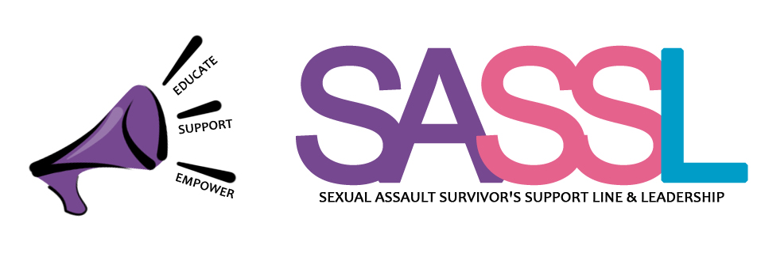
SASSL LEVY OPT-OUT AND REFUND FUND
First Name:

Last Name:

Organization you are opting out from:

Please explain the reason why you are opting out of the organization so they can better understand your rationale (optional):

Signature: Date:

Please submit this completed form, plus:

- Print out of timetable that is dated between November 11 – 25 2017.
- Photocopy of YU Card

Bring the entire package to the organization you wish to opt out of for processing. You must submit a different form to each organization:

- Centre for Women and Trans People(CWTP), 322 Student Centre
- Ontario Public Interest Research Group (OPIRG), C449 Student Centre
- Sexual Assault Survivors' Support Line & Leadership (SASSL), B449 Student Centre
- World University Service of Canada (WUSC) Centre For Refugee Studies, 8th Floor, York Research Tower
Top of Form

